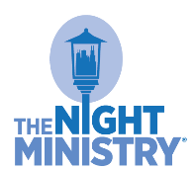

The Night Ministry’s Giving Tuesday Toolkit 2019

On Giving Tuesday, we hope that you will help us spread the word about The Night Ministry’s mission. We invite you to encourage your social network to support The Night Ministry and our programs for youth and adults experiencing homelessness or poverty in Chicago. In this toolkit, you will find some helpful background information about Giving Tuesday, as well as sample social media messages that you can post to social media.
Date: Giving Tuesday, December 3, 2019
About Giving Tuesday: In 2012, the United Nations Foundation started Giving Tuesday in response to the commercialism and consumerism in the post-Thanksgiving Season (Black Friday and Cyber Monday). The idea behind Giving Tuesday is to set aside a day during the holidays for giving back.
Goal: To raise over $80,000 for The Night Ministry in online gifts on Giving Tuesday, and to encourage at least 10 new supporters to launch Facebook Fundraising Campaigns on Giving Tuesday.
Theme: What does home mean to you?
Giving Page: https://thenightministry.ejoinme.org/MyPages/GivingTuesday/tabid/568733/Default.aspx
Background: People experiencing homelessness don’t just need a roof over their heads and four walls to shelter them. They need a foundation of support and compassion. They need the warmth, safety, and relationships that form a true home. We all do! On Giving Tuesday, The Night Ministry will share the power of #Home through stories and testimonies from our community. What does #Home mean to you? On Giving Tuesday, we invite you to post your response on social media and tag The Night Ministry.
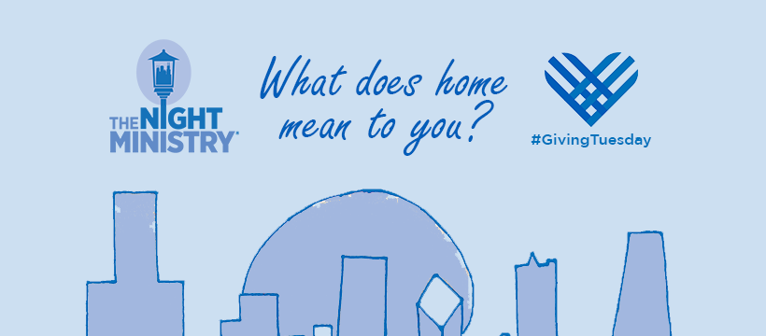
Cover/Banner Photo:
We have created a banner photo for Giving Tuesday that connects people from across The Night Ministry:
The banner highlights Chicago—home to all clients of The Night Ministry, and many of our supporters. The skyline image was drawn by Daniel, a young adult client of The Night Ministry. You can use this image as your cover photo on Giving Tuesday!
Facebook Frame:
We have also created a special Facebook frame especially for friends of The Night Ministry on Giving Tuesday. Please update your profile on Facebook to include this frame:
- Log-in to Facebook
- Go to your Profile page
- Hover mouse over your profile picture and click “Update”
- Click “Add Frame” in the pop up window
- Search for and select “2019 #GivingTuesday The Night Ministry”
- Click “Use as Profile Picture” at the bottom
Create a Facebook Fundraising Campaign:
Did you know that you can create fundraisers for nonprofits on Facebook? It’s easy, convenient, and has proven to be very successful! We encourage friends of The Night Ministry to create a fundraiser on Giving Tuesday. For easy instructions go to https://www.facebook.com/fundraisers/ or follow these steps:
- Login to Facebook
- Click Fundraisers in the left menu of your News Feed.
- Click Raise Money.
- Select Nonprofit/Charity.
- Select “The Night Ministry,” choose a cover photo, and fill in the fundraiser details.
  - Set a goal that you would like to raise from your family and friends.
  - Share why The Night Ministry is important to you.
- Click Create.
If you need help updating your background photo or frame on Facebook, or starting a Fundraising campaign, please contact Bethany Collins at bethanyc@thenightministry.org.
Post on Facebook:
The Night Ministry will post stories of #Home on Facebook throughout the day on Giving Tuesday (and throughout the week). Please feel free to share our post(s), and write a brief introduction at the top of your re-post, such as:
“I am connected to The Night Ministry as a volunteer. Together with The Night Ministry clients and staff, we are providing the elements of #Home to young people and adults experiencing homelessness. Help us share the warmth of #Home on #GivingTuesday. Give to @TheNightMinistry today.” [SHARE TNM POST] https://bit.ly/2MU7cNL
Write Your Own Post:
“To kick off the holiday season, I am supporting the causes close to my heart, like @TheNightMinistry, which provides Housing, Health Care, and Human Connection to those who need it most. Join me in making a #GivingTuesday donation to @TheNightMinistry and help us provide the warmth of #Home to The Night Ministry’s clients.” https://bit.ly/2MU7cNL
Example - Bethany’s Facebook Post:
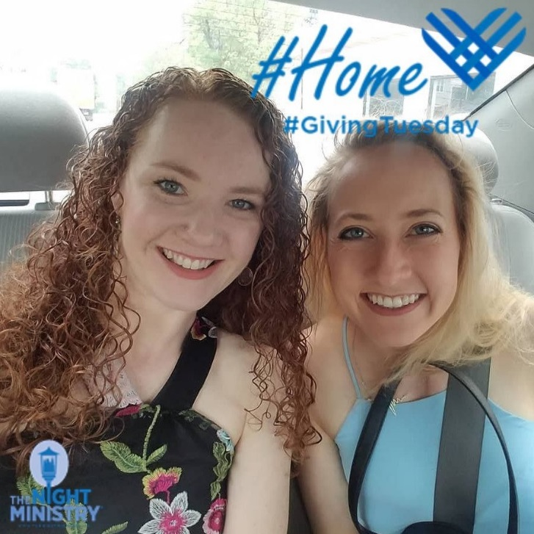
“Today, #GivingTuesday, I am reflecting on what #Home means to me. Throughout my life, my home has been a place where I was free to be myself, no matter how silly or stubborn—and even encouraged to show my true colors to the world. I know that many clients of The Night Ministry have not felt free to be themselves in the various places they have called home I am proud to work for @TheNightMinistry, a Chicago nonprofit that, first and foremost, builds relationships with people experiencing homelessness. The young people and adults who stay in The Night Ministry’s shelters, or receive health care from our Outreach and Health Ministry, are welcomed and accepted without judgment, no matter who they are or what they are going through. This #‎GivingTuesday, please join me in making a donation to @TheNightMinistry and provide the warmth of #Home to homeless young people and adults across Chicago. Share what #Home means to you and donate today! ‬‬‬‬‬‬‬‬‬‬‬‬‬
Sample Tweets:
On #GivingTuesday, I want to provide the warmth and safety of a true #Home to Chicago’s homeless, so I’m supporting @NightMinistry. GIVE today to TNM! https://bit.ly/2MU7cNL

This is what #Home looks like. [INSERT PHOTO] The relationships I’ve built through @NightMinistry inspires me to donate to on #GivingTuesday. https://bit.ly/2MU7cNL

Proud Volunteer at @NightMinistry. Help me serve homeless youth & adults on #GivingTuesday. GIVE today! https://bit.ly/2MU7cNL

My donation 2 @NightMinistry will support Chicago’s homeless young people. Provide #Home and GIVE today! https://bit.ly/2MU7cNL
Sample LinkedIn Post:
Because LinkedIn is a hot spot for professionals, begin with a brief introduction about your professional involvement with TNM, such as:
“I am a regular volunteer at @The-Night-Ministry, and I believe in this organization and its work with homeless youth and adults in my community. Every day @The-Night-Ministry offers a lifeline to forgotten members of our community. Staff and volunteers help to meet the physical needs of the homeless – food, medical care, housing – and, even more importantly, The Night Ministry provides a foundation of support and compassion. I’m making a donation to The Night Ministry on #GivingTuesday to support its programs that provide Housing, Health Care, elements of a true #Home, to youth and adults experiencing homelessness. I encourage you to give to @The-Night-Ministry today!
Sample E-mail:
Dear _____,
December 3 is #GivingTuesday, a national day of giving to kick off the holiday season, and I am proud to support The Night Ministry. I hope you will, too!
As you know, The Night Ministry is a cause that is close to my heart. As a volunteer, I have the privilege of witnessing their important work with Chicago’s homeless firsthand. I’m continually inspired by the Health Outreach Bus and Street Medicine team, which bring free, compassionate medical care to underserved communities. The Night Ministry also supports young people who are homeless and who worry about where to sleep at night, eat, shower, and stay in school to build a future. Each person’s situation is unique, but they all have a common hope of improving their lives through The Night Ministry’s programs.
On Giving Tuesday, The Night Ministry’s ambitious goal is to raise over $80,000 to support people experiencing homelessness. You can give by visiting [https://bit.ly/2MU7cNL] or by purchasing items off of The Night Ministry’ Amazon Wish List.
Thank you for helping me provide housing, health care, and human connection to members of our community struggling with poverty or homelessness.
Warm wishes,
(Your Name)
TNM Donation Page:
https://thenightministry.ejoinme.org/MyPages/GivingTuesday/tabid/568733/Default.aspx
Or shorter version that goes to same page: https://bit.ly/2MU7cNL
TNM Amazon Wish List: https://www.amazon.com/hz/wishlist/ls/2ZT242CJGBVW5?ref_=wl_share

